## FRESH BITES CATERING

## 1.Introduction

Fresh Bites Catering is a dynamic and innovative catering company that has established itself as a leading provider of culinary experiences. Known for its dedication to quality, creativity, and exceptional service, Fresh Bites Catering has become a trusted choice for a wide range of events, from intimate gatherings to large-scale corporate functions and weddings.

## Overview

Fresh Bites Catering is a well-established and highly regarded catering company specializing in delivering culinary excellence for a wide range of events and gatherings. With a focus on quality, innovation, and impeccable service, Fresh Bites Catering has become a trusted name in the catering industry, known for its ability to turn every occasion into an unforgettable dining

## Purpose

1. Fresh Bites Catering aims to provide top-tier culinary experiences. The primary purpose is to offer exceptional and delicious food that satisfies diverse tastes and exceeds the expectations of clients and their guests. This culinary excellence is at the heart of the business..

## 2.Problem Definition &Design Thinking

## 2.1Empathy Map

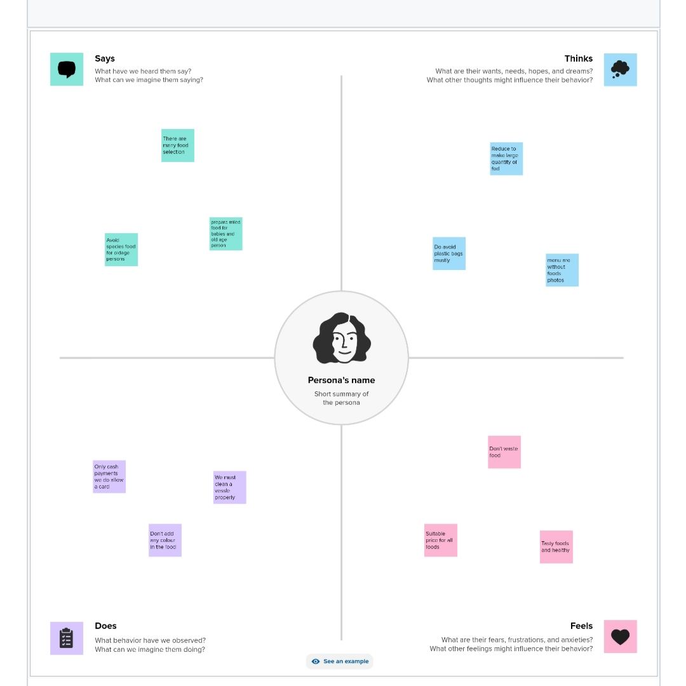

## 2.2 Ideation &Brainstorm Map

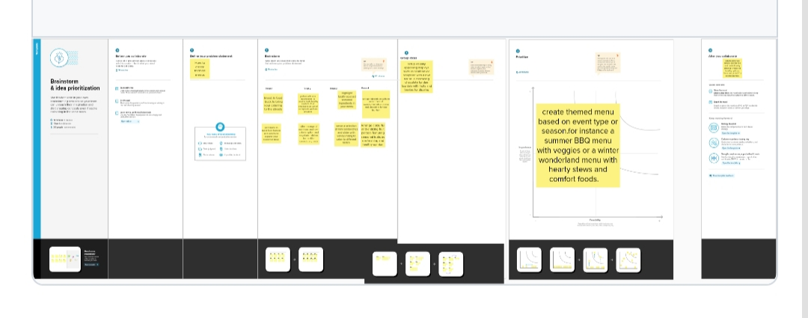

## 3.Result

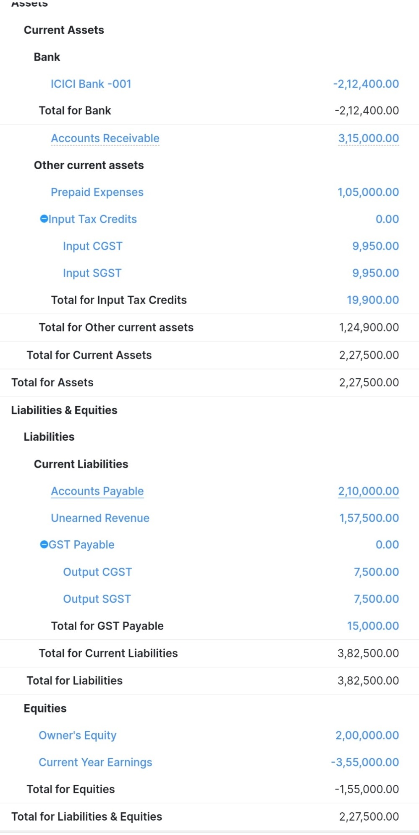

## 4.Advantages &Disadvantage

Fresh Bites Catering is known for using high-quality, fresh ingredients in their dishes, ensuring

that the food they serve is delicious and of excellent quality. They offer a diverse range of menu choices to cater to various tastes and dietary preferences, providing a wide selection for clients to choose from. Fresh Bites Catering can create customized menus to suit the specific needs and preferences of clients. This allows for a more personalized dining experience at events. The company is staffed by experienced professionals who are dedicated to providing excellent customer service, from planning and preparation to on-site service during events. Fresh Bites Catering pays close attention to the presentation of their dishes, making them visually appealing

### Disadvantage

High-quality catering services can be expensive, and Fresh Bites Catering may not be budget-friendly for all clients. Depending on their popularity and existing bookings, Fresh Bites Catering may not be available for last-minute or short-notice events. Their services may be limited to certain geographical areas, which can be a disadvantage for clients in regions where they don't operate. If you prefer a more hands-on approach or have specific preferences for self-catering, Fresh Bites Catering's full-service approach may not align with your needs. Due to their popularity, you might need to book their services well in advance, which could be a disadvantage if you have a spontaneous event.

## Mission Statement: "At Fresh Bites Catering, our mission is to delight our clients and their guests with exceptional culinary experiences. We are dedicated to providing delectable, fresh, and innovative catering solutions that not only meet but exceed our clients' expectations. Our commitment to quality, creativity, and customer satisfaction drives us to deliver memorable dining experiences, making every event special and unforgettable."

Vision Statement: "Our vision at Fresh Bites Catering is to be the leading provider of catering services in our region, known for our unwavering commitment to quality, creativity, and exceptional customer service. We aspire to be the go-to choice for clients seeking a partner to make their events truly special through the power of exquisite, fresh, and innovative culinary creations. We aim to expand our reach, diversify our offerings, and consistently raise the bar in the catering industry while upholding our values of integrity, sustainability, and community engagement .

## Conclusion

In conclusion, Fresh Bites Catering is poised to leave a lasting mark in the catering industry. Their dedication to quality, creativity, and customer delight ensures that every event they touch becomes a memorable and special occasion. With a focus on expansion, diversification, and community engagement, Fresh Bites Catering is well-positioned to lead the way in redefining the catering experience and setting new standards for excellence in the industry.